**EYEMAX NKB1000 KEYBOARD**

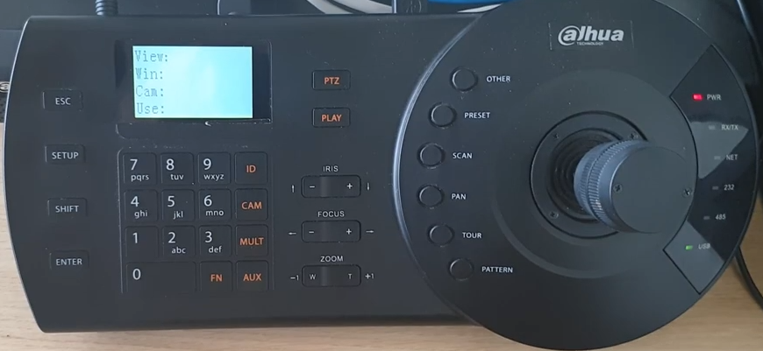

**Quick installation Guide Rev 1**

**SETUP PROCEDURE using a Ethernet connection to a NVR , DVR or SD ( PTZ camera)**

Press Set up

User admin

Pass: 888888

**MENU SETTINGS** -> SYSTEM

Adjust **Date and Time** / ESC

**NETWORK**  - Settings - DHCP or Static IP ( this is the Keyboard IP address)

**ZONE.** Each NVR it is assigned to a Zone . Example if you have 8 PTZ cameras , the NVR still needs one zone

* ID -1 ( zone #1 for example )
* Name :TEST
* Type : NVR. SD ( for dome)
* LINK . NET

Scroll down

Setup

IP ADDRESS of NVR

Port 37777

Step ( speed ) 8 (higher means faster)

Scroll down

RULE DH-2

User : system ( of NVR)

Pass : ***** ( of NVR

Press ENTER TO SAVE

ESC

**MAIN MENU**

User admin

Pass: 888888

ZONE CONTROL

MENU SETTINGS

Select Zone - Press Enter

ID1 ( Zone #1) Enter

If connection is **successful** will show

ID :1

Type : NVR ( SD if is for PTZ)

IP : IP address ( of NVR)

**To use PTZ**

Make sure the PTZ is assigned to Channel 1

Press 1 then PTZ

Press 2 then PTZ

**Preset Set up**

Login m

User admin

Pass: 888888

PTZ camera must be properly configured

Example

**Preset #1**

Move camera to desired position

Press Preset

Press #1 button

Press SET ( Enter)

GOTO Menus

Select preset #