Mobile Monitor Instructions

1Install and Uninstall

1. Install and Uninstall for Android

1. 1 running environment
System: SmartHD Support Android os 2.1 and above versions
Support phone: HTC G1,HTC Magic,HTC Hero,HTC G5, Motorola, SAMSUNG and so on.

1.2 Install
User can get the Smart HD from two way: download from the Paly Store or get it from the Incidental CD-ROM.
- Download from the Paly Store
Open the“Paly Store”on your cell phone，Enter the“Smart HD”to the search bar, then download
And install it as picture1 show:
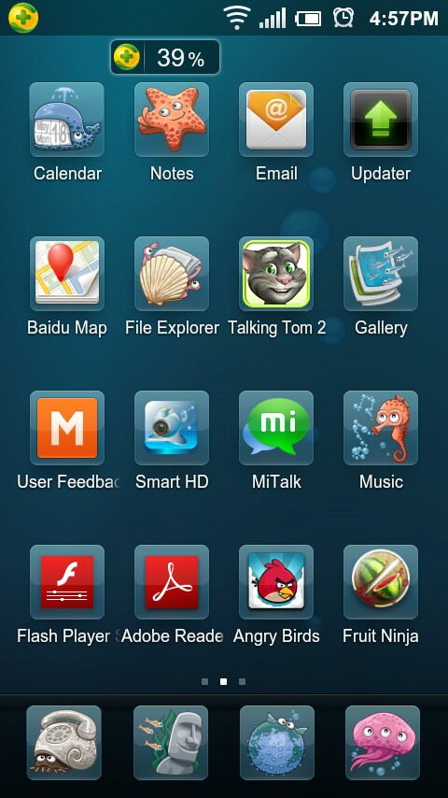
picture1
- get it from the Incidental CD-ROM
you could find it from the Incidental CD-ROM,just copy to your cell phone to install
install complete as picture1 show:

1.3 Uninstall
Press Setting->Applications->Manage applications->find the SmartHD as picture2 show，click SmartHD icon ->Uninstall as picture3 show.
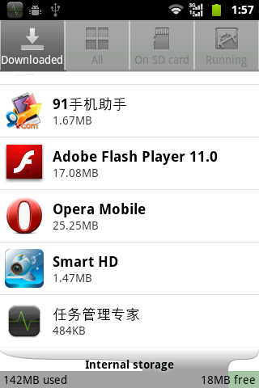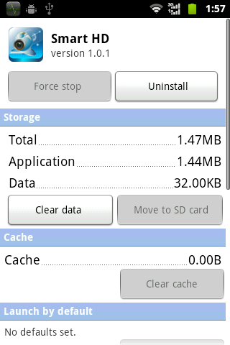
picture2 picture 3

2. Install and Uninstall for Iphone
2.1. System requires
Support Device | iPhone or iPod 2.0 or greater is required
Space Required | >800 KB Free space
Software required | iTunes（optional）
2.2. Install
1) Open your iPhone and click App Store.
2) Under search bar ,typing “SmartHD”and click search button. Download the Mobile Viewing Application for free, the file name is SmartHD.
3) Click the SmartHD icon, The application begins to install on your iPhone.
2.3. Uninstall
Under your iPhone main menu，Press and hold the SmartHD icon for a few seconds，you will see the Delete Button to uninstall the SmartHD.

3. Install and Uninstall for BlackBerry
3.1 System requirement
Smartphone OS: 5.0
The mobile that supports：
CURVE 8900
BOLD 9700
TOUR 9630
3.2 installation
1) please install it by “Cod loader”
Please connect Blackberry phone with computer via USB cable.
Run “Cod Loader” and synchronize mobile phone，when the synchronization is successful，please add “SmartHD.cod”, install it to complete the installing process。
- please disconnect the USB cable, in the “BlackBerry Desktop -> Download”, you will see the “SmartHD” icon.
  - Uninstall
please install it by “Cod loader”
Please connect Blackberry phone with computer via USB cable.
Run “Cod Loader” and synchronize mobile phone，when the synchronization is successful，please select the “SmartHD” to uninstall

2 Software operation

Remarks：Software operation part with Android version as example to introduce，The other version similar to the operation

2.1 Main Interface
Press“SmartHD”to open the software ，the main interface as picture4,the Live view window as picture5.
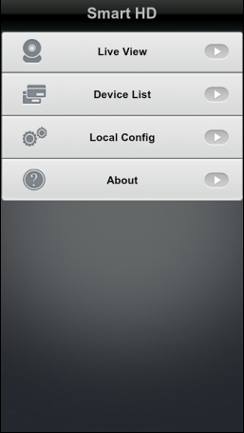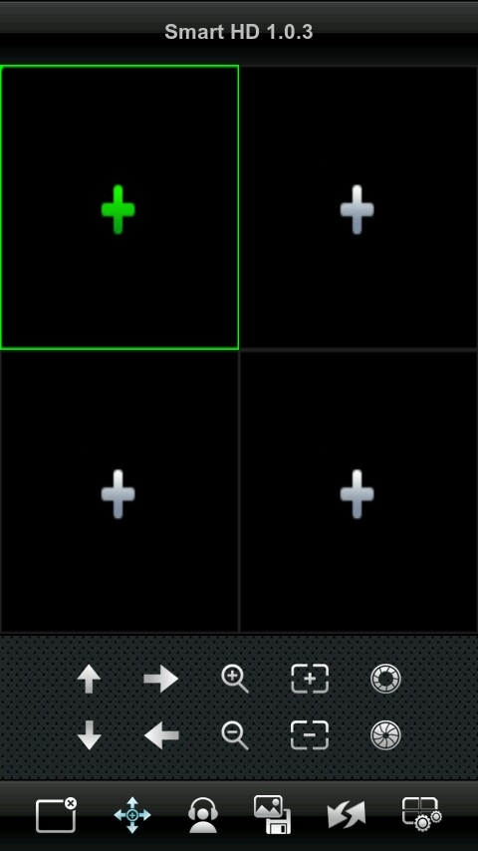
picture 4 picture 5

2.2 Add/Delete device information

2.2.1 Add Device
1、Press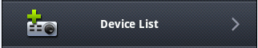 to enter the Device List panel，then press the “Add”button on the upper right corner to enter the Device Info panel (the first time open the Device list will pop a window ask if need to add device, as picture 6 show).

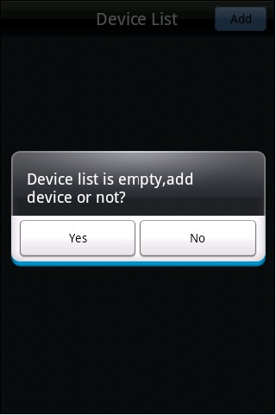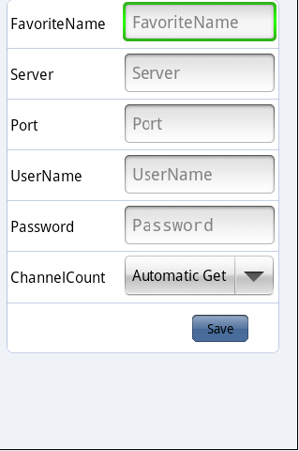
picture 6 picture 7
- Enter the Device Info:
>> Favorite Name: Enter any strings that you like to distinguish this device from the others.
>>Server：Your DVR’s IP address ,it also can be a Dynamic Domain Name(Note: if need the remote connection, strongly suggest enter a WAN address ,if enter a LAN address, it will only work on the LAN network.)
>> Port：Enter the DVR’s cell Phone Port(or call mobile port),you can find it form
the DVR’s setting panel or user guide.(note: have you make the port forwarding to the router? If haven’t, just do it, otherwise you will fail to make a remote connection)
>> User Name/Password: you could find and change them from the DVR’s setting panel
>> ChannelCount：DVR’s channel numbers，you can set manually or press the “Automatic Get”item to
Get channels number automatically.
Click“Save ”to finish and go back to the Device List.
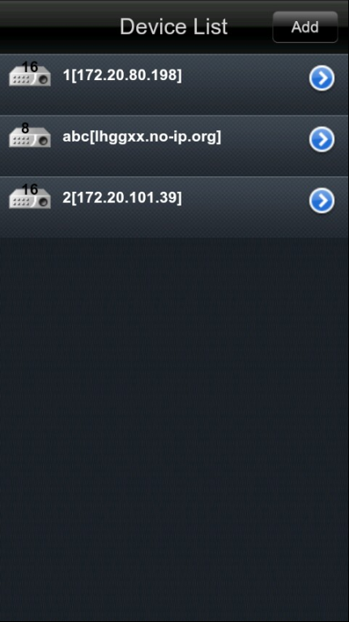
picture 8

2.2.2 Delete Device.
Press the button behind the certain Device that you want to delete, into the setting panel as picture 9,Click” Delete” button, then choose delete or not in the deletequery.tbl as picture10 show:
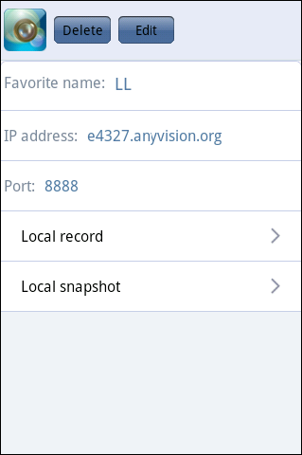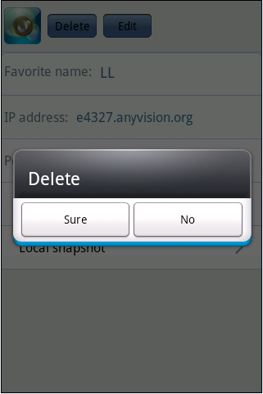
picture 9 picture 10

2.3 Live View
o view the DVR’s video when finish edited the login info, Press 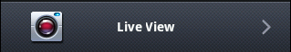，then the playing window will show as picture 11:
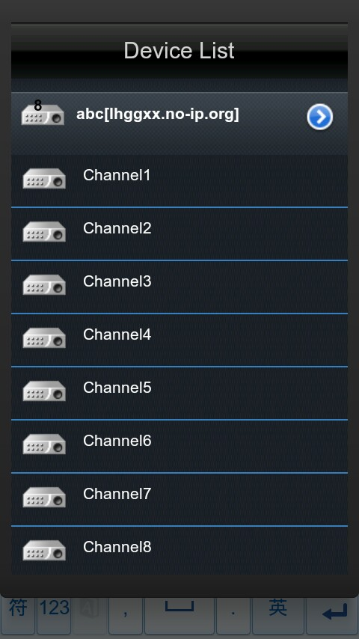
picture 11 picture 12

2.3.1 Video Playing
In the Live View panel ,click one of the window to open Device List as picture12, click the Device name to expand the channels ,now just press the channel you want to play then you can viewing the video.
Case you want to view more channels at the same time ,just select another windows to repeat the step.
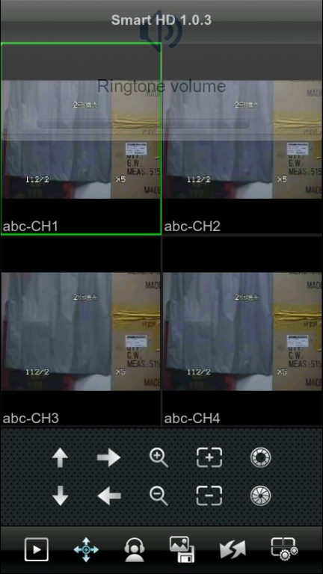
picture 13

2.3.2 Button Description
The table below is all of the buttons description on the Live View panel:

Button icon | Button name | Description
 | PTZ:UP | Camera move up
 | PTZ:DOWN | Camera move down
 | PTZ:RIGHT | Camera move right
 | PTZ:LEFT | Camera move left
 | ZOOM IN | draw the camera lens from far to close
 | ZOOM OUT | draw the camera lens from close to far
 | FOCUS ADD | adjust focus near
 | FOCUS MINUS | adjust focus far
 | IRIS ADD | adding the aperture
 | IRIS MINUS | Subtracting the aperture
 | CLOSE/REOPEN | Close the selecting window/Reopen the selecting windows
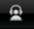 | monitor sound | monitor sound
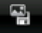 | screenshots and videos | Local screenshots and The local mobile phone video switch
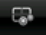 | Channel configuration | Access channel color configuration interface（Need a connection channel）
Table 1

2.3.3 Full Screen playing
The SmartHD support landscape and Portrait mode. switch to the landscape mode when playing, the playing windows will turn to the full screen playing as picture 15 show.
Click one of the four windows can play it in full screen ，if need to control the PTZ on full screen ,you can use the finger touch operation:
>> Zoom in: Touch and move your fingers away from each other .
>> Zoom out: Touch and move your fingers towards each other.
>> Pan operation: Touch and move one finger up, down, left, right.
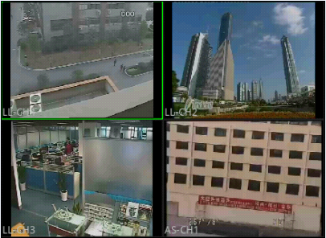
picture 15
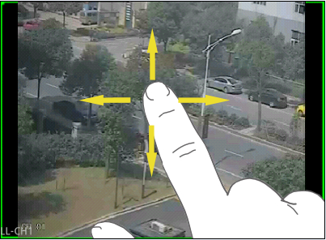
picture 16

2.4 Manage the snapshot.

2.4.1 Viewing Snapshot Picture.
Press the button behind the certain Device that you want to check, as picture7 show, select the “Snapshot Pictures” Item into the pictures list(as picture9 show), then you can view the snapshots that you want.
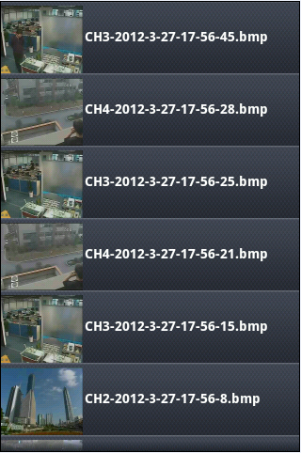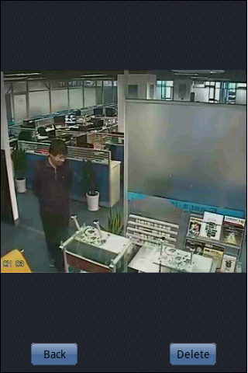
picture 17 picture 18

2.4.2 Delete The Snapshot Picture
When viewing the picture, press the “Delete ”button on the bottom right corner as picture18 show, then you could delete the picture.
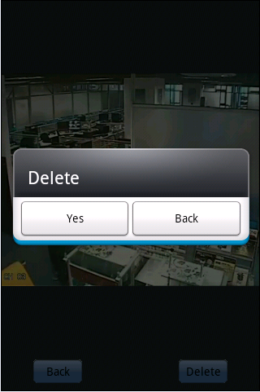
picture 19

2.5 Manage the record files

2.5.1 Playback
Press the button behind the certain Device that you want to check, as picture7 show, select the “Local Records” Item into the video records list(like picture20 show), click one item that you want to play, then press the “view” button on the bottom left corner as picture21/22 show.

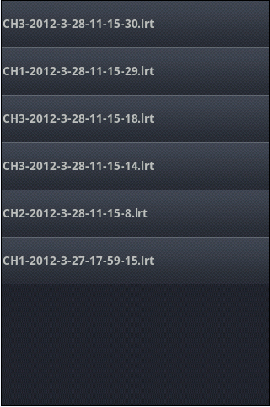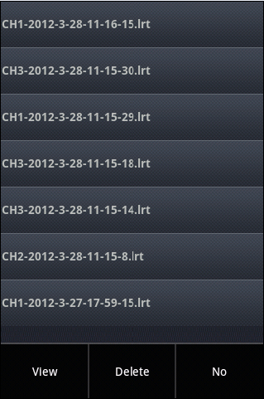
picture 20 picture 21
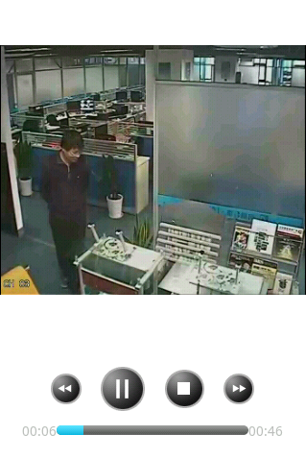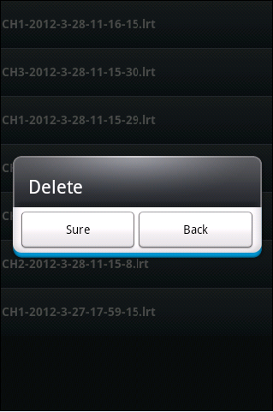
picture 22 picture 23

2.5.2 Delete the record files
Select the item that you want ,press the “Delete ”Button then click “Sure” then it will delete from your phone.

2.6 Help
Click the 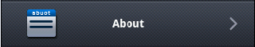 ，icon in the main interface of the SmartHD could open the help file.

2.7 Quit
Press the button then you can exit the SmartHD.

