DVR Upgrade Manual

Include two kinds of ways to upgrade : U disk upgrade and network upgrades

First: U Disk upgrade
- U disk inside the upgrade file copy. (U disk size of 2G-4G)
Upgrade folder name “dvrupgrade”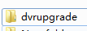
Folder for the update file:
- U disk connected DVR
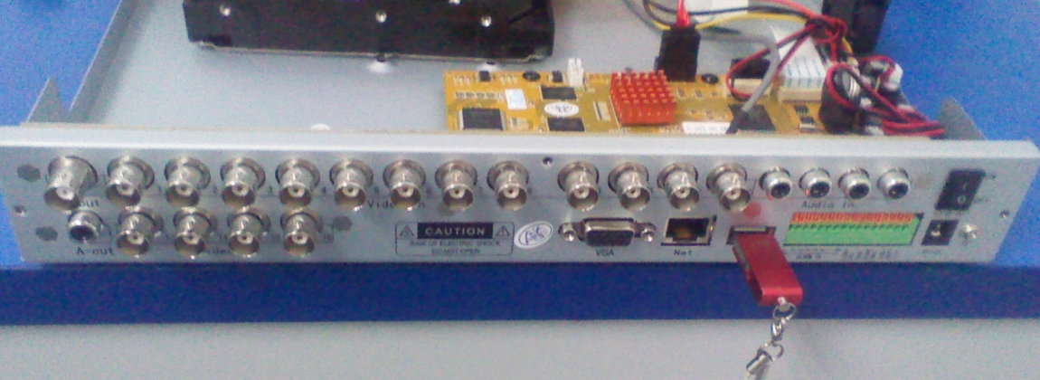
- Start the DVR, DVR connected monitor (BNC or VGA)
MainMenu-------System-----Maintain-----upgrade
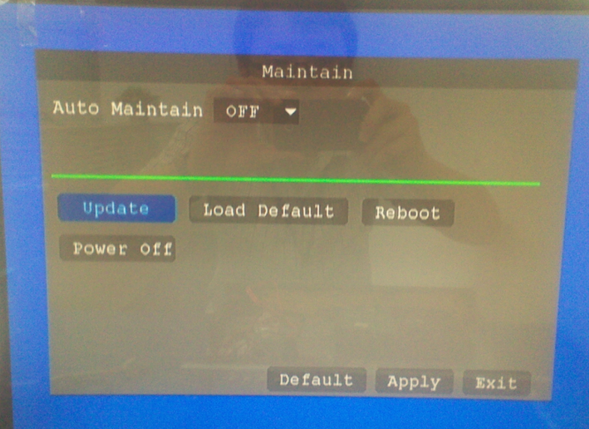
Choose to “upgrade”
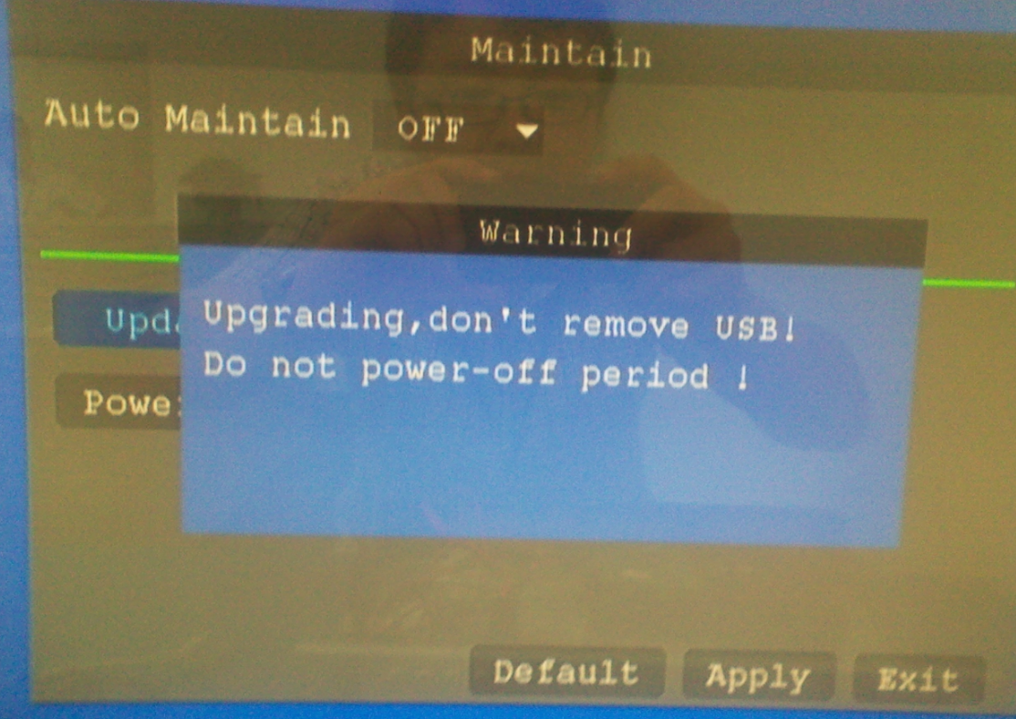
DVR Start the upgrade
PS: The upgrade process, please do not power off or unplug the U disk

Second: network upgrade
- DVR set up an IP, can connect to the network, computer can access.
- Open IE browser, Enter the DVR IP address.
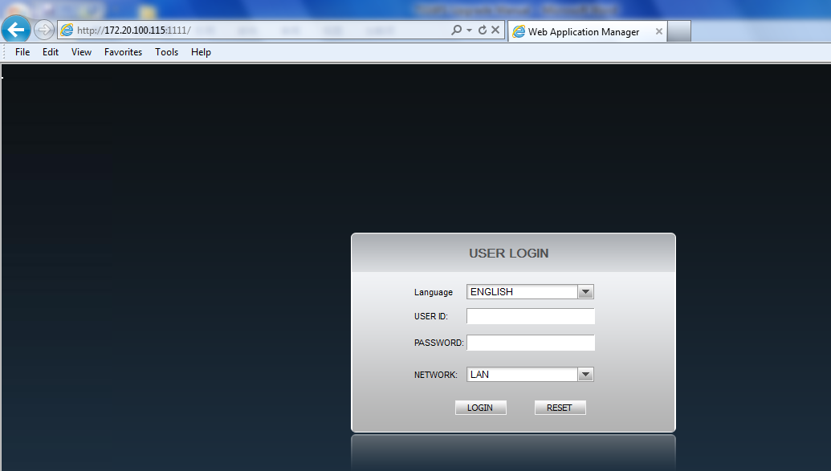
- Enter the login ID and password
ID: admin password: 123456
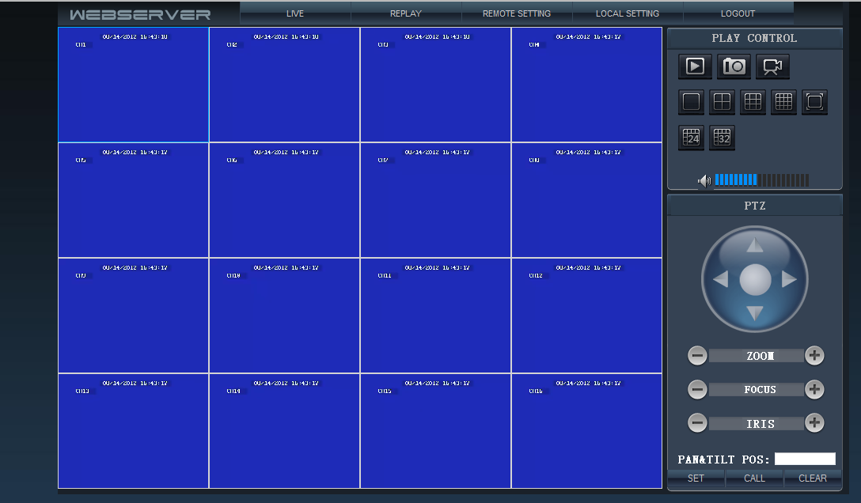
- Select Remote Settings
- Select “Maintenance”
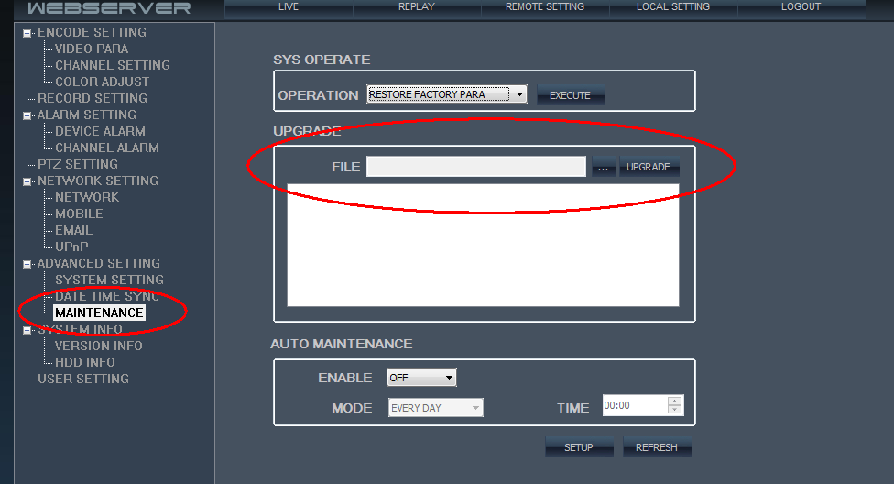
- Select the upgrade file, Click the “Upgrade”
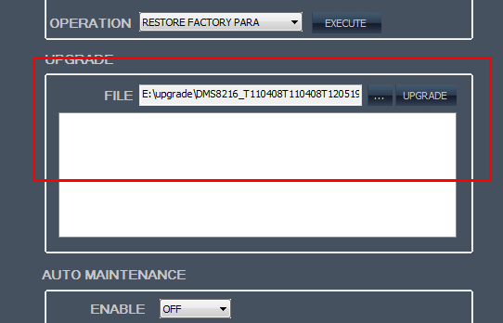
PS: The upgrade process, DVR will not power.
The upgrade process, The DVR will automatically restart.
