Probe IP Camera

Setup -> Device -> Hybrid Device -> Add
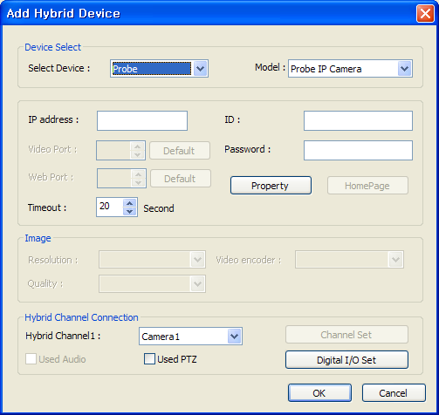

Click Property

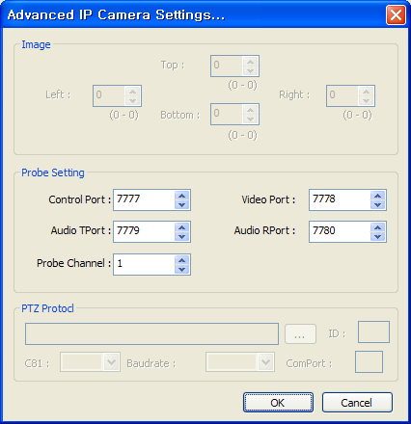

Make sure Probe Channel is in 1

PTZ Camera Setup
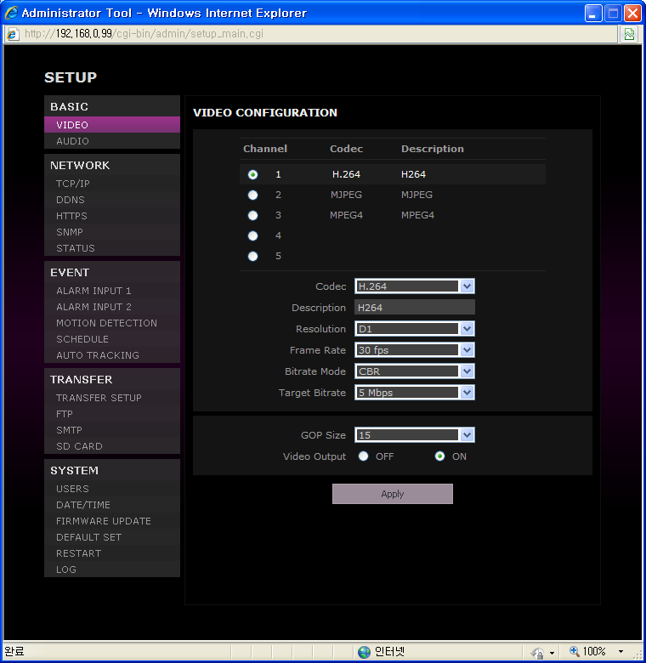
Make sure Channel 1 use H.264 Codec. The PC DVR can read only H.264 Codec.

The recommended Target Bitrate is 2Mbps.

