BLC-015 .User Guide

Version Eng-1.00



2. Spec

Item | SPEC | Remarks
Name | VIRDI BLC-015
Communiation | ① RS485 ② Wiegand
Power | DC 12V
In / Out | -. Door access  -. RS485, Wiegand  -. Battery In / Out

3. Configuration

3.1. Front

SW1
SW5
SW4
SW3
SW2

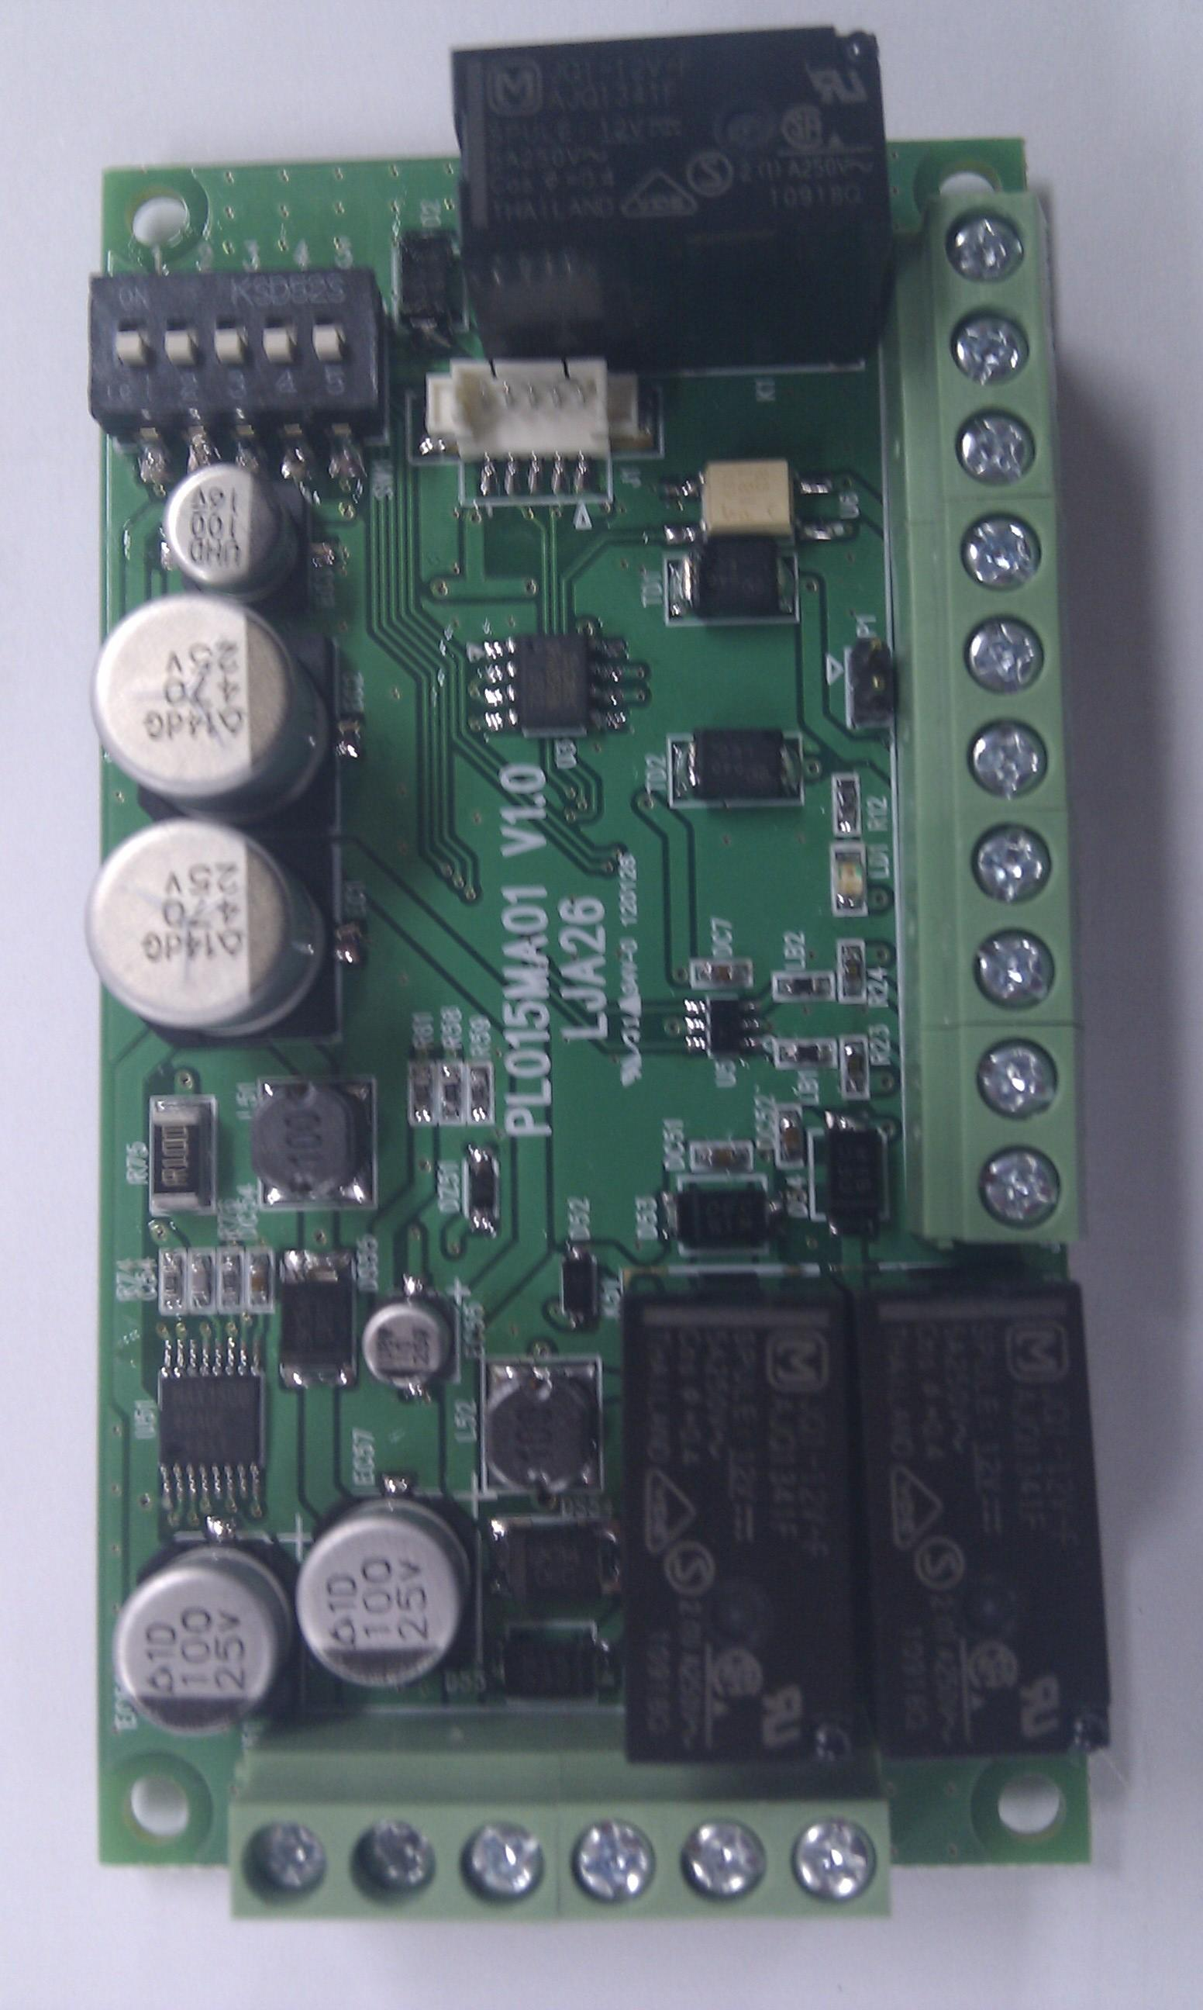
COM
WIN0

WIN1

GND

485A

485B

EXIT
GND
N.C.
N.O.

LED

12V IN
GND
12V OUT
GND
BAT(+)
BAT(-)

4. Setting

4.1. Controller ID

Dip Switch 1~2
No | Controller ID | Dip SW1 | Dip SW2
1 | 0 | OFF | OFF
2 | 1 | OFF | ON
3 | 2 | ON | OFF
4 | 3 | ON | ON

Use SW1 and SW@ to set up controller ID (01 ~ 04)

4.3 Set time of opening a door

Dip Switch 3~5
No | Open Seconds | Dip SW3 | Dip SW4 | Dip SW5
1 | 1 | OFF | OFF | OFF
2 | 2 | OFF | OFF | ON
3 | 3 | OFF | ON | OFF
4 | 4 | OFF | ON | ON
5 | 5 | ON | OFF | OFF
6 | 6 | ON | OFF | ON
7 | 7 | ON | ON | OFF
8 | 8 | ON | ON | ON

Use SW3 and SW4 to set up opening door time

5. Install and operation

5.1. Install VIRDI BLC015

1) Connect between Virdi terminal and BLC015 via RS 485 or Wiegand
2) Connect a lock to BLC-015
3) Set controller ID and opening door time
3) Power on a terminal and BLC-015
4) Check POWER LED on

5. Connection

5.1. Lock

1) Power

- Adapter power : 12V IN,GND
- Terminal : 12V OUT,GND
- Battery power : BAT(+),BAT(-)

2) Communication

- RS-485 : Connect 485A and 485B
- Wiegand : Connect WIN0 and WIN1

3) Lock

- Connect COM and GND
- Exit Button : Connect EXIT and GND
- Lock의 (+) ➔ 12V OUT
(-) ➔ NC (NO)

